Importing Trade Rates
Example Attached as “BC Trade Rate Import Template – Feb 2025.xlsx”

- After the trade rates are prepared by Daisy, they are copied and pasted into a template file that converts the names Daisy uses to the rates and categories used in BC. The data does not need to be edited, just copied and pasted.
  - Every month I take the previous template, delete the previously pasted data in columns A ~ E, past in your new data, and save the file for import.
    - The old instructions below are pre-Chapstick and say A ~C, the new instructions are updated.
    - It is also important to note the mapping values for the rates as they exist in the template will need to be updated if new budgets or added.
      - This is beyond the scope of these instructions as the import template is a tool to get the rates in, but it does not need to be used if users are tasked with manually updating the trade rates by hand or with a Config Package.
  - 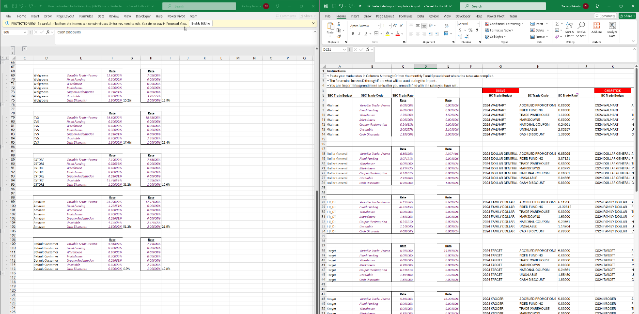
- The template file is saved and dropped into BC using a report called “Process Import Template”
  - Search in BC for this report by the name in quotes and make sure that your Export Definition Code is SBC-Rate-Import.
  - 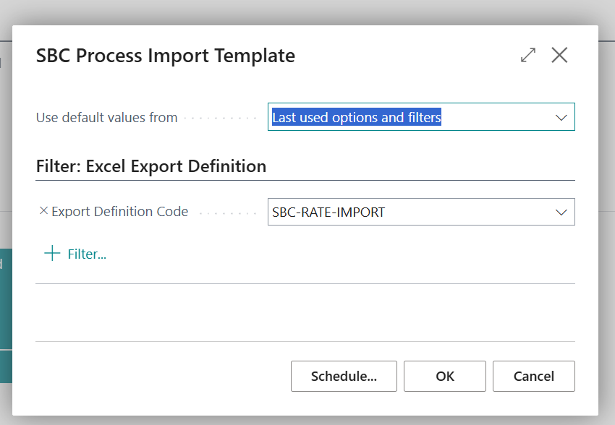
  - After pressing OK, the drop file or browse dialog below will appear. Either drop the completed template on this screen or browse to the file.
  - 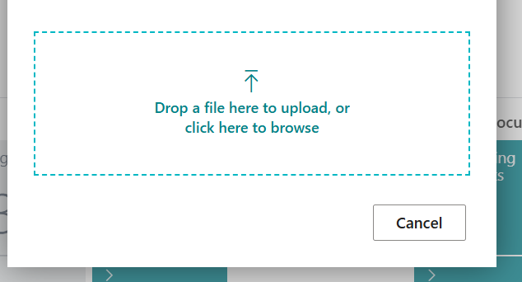
  - Dropping the template file on the screen above is enough to update the rates for Suave and Chapstick.
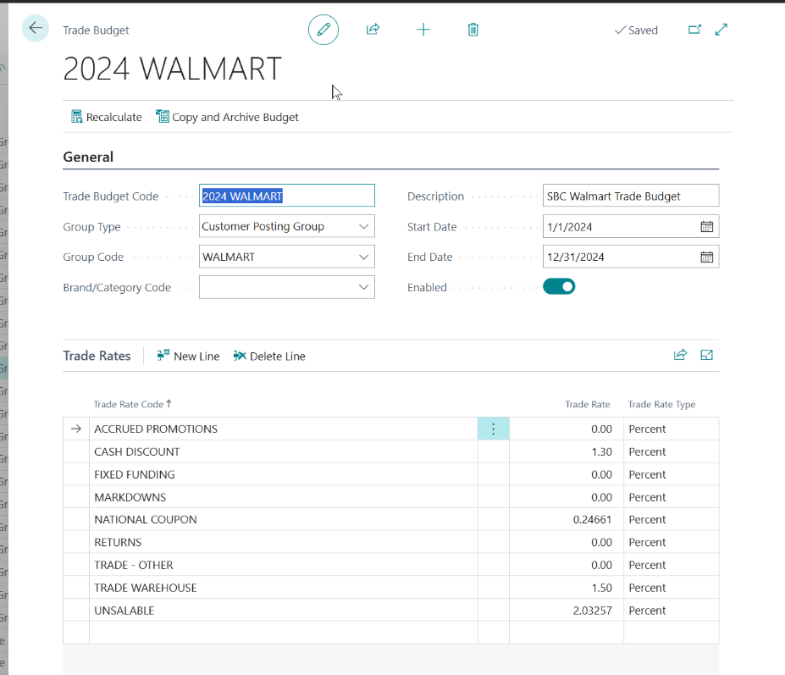

Running Trade
Trade Budgets > Then Clicking the “…” context menu to see “Actions”, if it’s not visible > From there she can select, Create Trade Ledgers

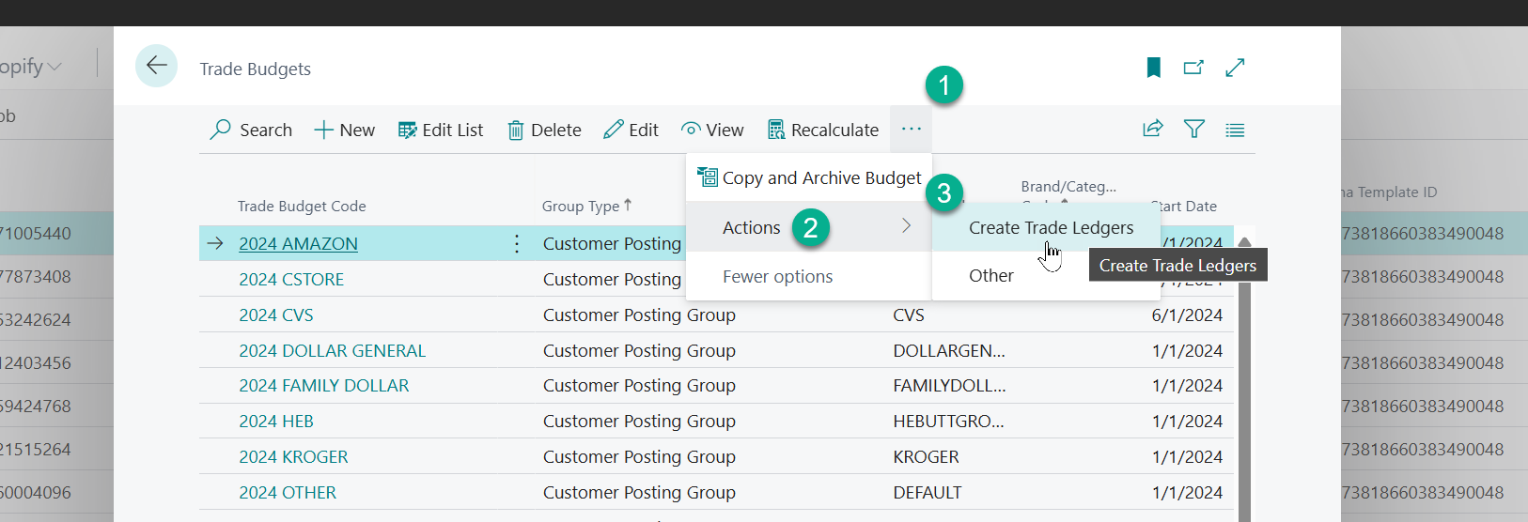

From this screen, she will have to set the date range, as it is not there for her—it will be blank:

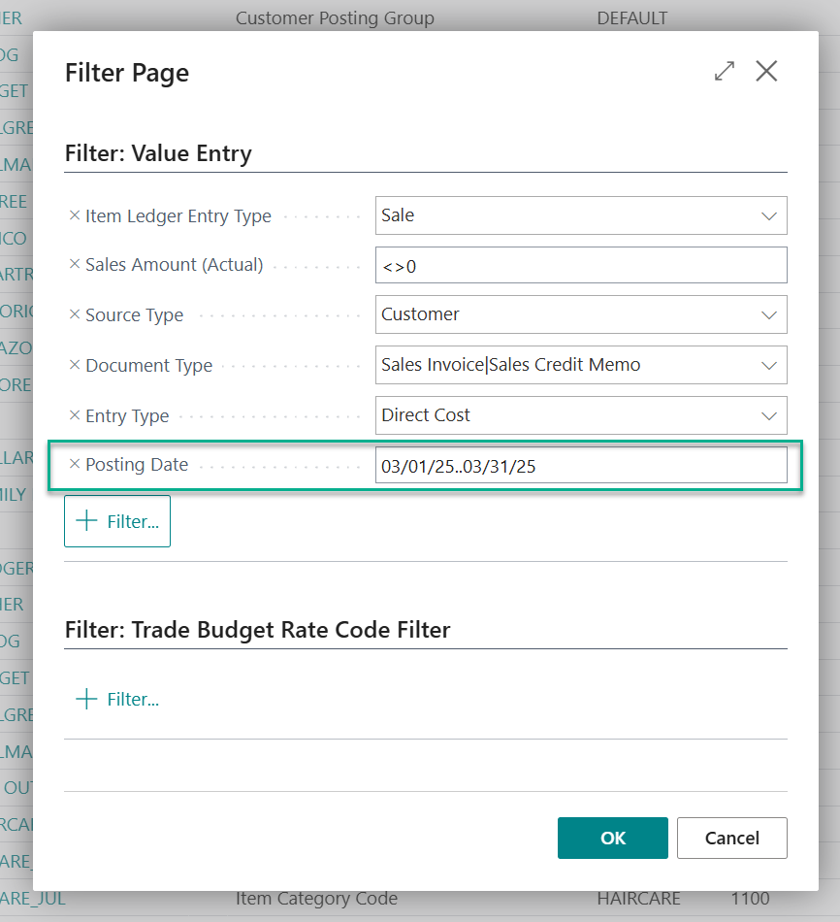

Create Trade Journals
After completing the steps to run trade for the period, go to the “General Journal” and press “Create Accrual Journals”. You will have to set the dates in the options page below as they will not be set for you as in the image below:

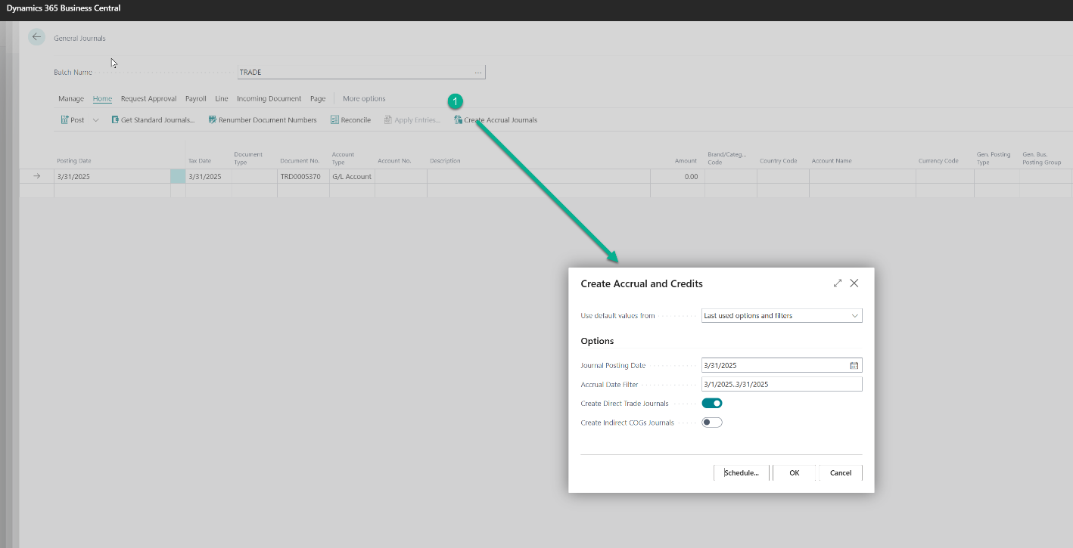
When this is done, you will be able to review the journal entries.

Creating the Review Document
Example Attached as “Trade Journal – Feb 2025 -2.xlsx”

To create a review document from the accrual journal that was created in the step above:

- Export the Journal Entries in the Trade batch of the General Journal to Excel.
- Within Excel, create a Pivot Table with the data using this field orientation for the fields of Description and Amount.
- You can also preview post within the journal, as well, to get more details on how the eventually posting will hit the GL, if that is desired.
